Personal Study Plan
MATILDA BRIMELOW
Define the objective or focus of the essay:

The focus of the essay – Is it possible to explore street photography using light?
How does Henri Cartier Bresson incorporate high contrast and a cinematic feel to his photos? I will consider how Henri Cartier Bresson used the decisive moment and how the decisive moment is also used in Ernst Haas’s photographs. I will compare Fan Ho and Ernst Haas photographs both reflect the importance of light one displaying the effect of light using natural lighting and one focusing on the absence of light in an image.
‘The decisive moment’- Henri Cartier Bresson.
The relationship between the practical work and the focus of the study:

I am focusing on street photography where I will be taking photos using an iPhone and a manual camera to explore the effect of lighting on the streets – ‘pockets of light’. Initially I will focus on shadowing and specific areas where light is present and as I go into depth in my project, I will explore the use of light at night, and colors exposed by light in the streets aswell as isolation of subjects. This will link to the focus of the study as I will be focusing on the Henri Cartier Bresson’s ‘The Decisive Moment’ a how the decisive moment effects street photography in terms of light.

Adapted: effect of light in street photography and in my own work I will take photos via using the absence of light and by using the natural use of sun rays in the daytime.
Sources to be used:
Books (at least THREE): | Websites: | Other sources:
Henri Cartier-Bresson – Interviews and Conservations.  1951-1998  Henri Cartier-Bresson – Aperture.  Mario Algaze – A respect for Light.  1974-2008  Vivian Maier – Street Photographer.  Magnum Photos Book. | https://kingjvpesphoto.com/blog/2018/9/11/my-street-photography-book-recommendations  https://www.theguardian.com/artanddesign/gallery/2014/aug/20/fan-ho-hong-kong-street-photography-in-pictures  https://aboutphotography.blog/photographer/fan-ho

List the pieces of work that you will analyse in the study. Identify reasons for choosing these particular pieces and points that may be highlighted in the analysis. Mark the primary source/s with *
Name of piece:  Rush Hour, New York City* | Reasons for choice/Points to be raised:
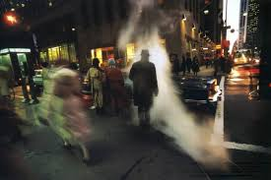  Afternoon Chat, Hong Kong 1959:  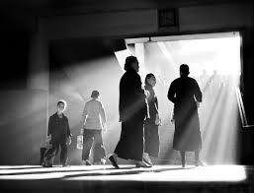  Fan Ho: Hong Kong Yesterday 1950s-1960s  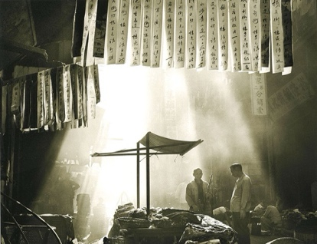 | Captures the intense and chaotic energy of New York city. The use of light demonstrates the urban motion and navigates the viewers eyes throw the imager and the crowded streets. It embodies the energy, chaos and determination of life in New York. The simultaneous use of light, colour and shadowing gives a cinematic feel therefore providing a story for the image contrasting to the image being so chaotic.  The rays of light capture a positive feel to the movement of the photo. They express positivity in the sense of highlighting the humans and leaving the rest of the building in the dark. This expresses the way, light can be used to tell a story.  Yesterday: Light rays – natural light connote positivity among the dark Hong Kong markets.
Visit/s made/to be made:

Manchester – Northern Quarter.
Possible conclusion/s to the study:
Demonstrating that light is the tool to every photograph and the effect of it displays am movement which leads to a story.

